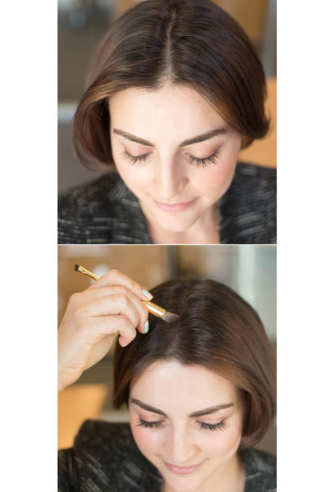***New tips for Looking gorgeous .***

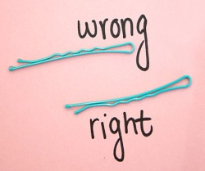***1.. For better grip, flip the bobby pin over so the wavy side is against your head.***

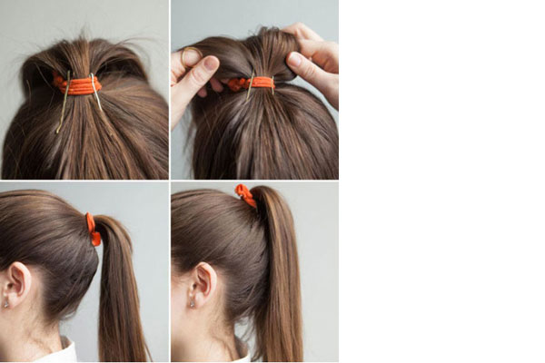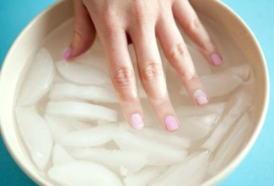***2. Insert bobby pins into your ponytail holder vertically to prop up your ponytail.***

Once you've put your hair in a ponytail, insert two or three bobby pins halfway inside the elastic and facing downward toward the crown of your head. Then, fluff your ponytail and flip it over for a fuller look that won't sag or droop.

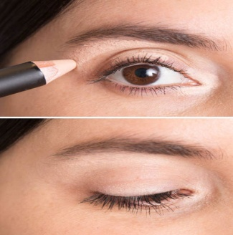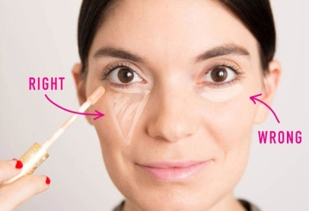***3. Twist your hair, and slip your bobby pin underneath to discreetly pin back your strands*.**

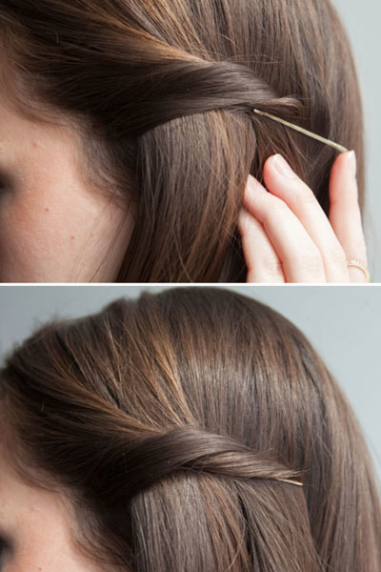If you're looking for a way to pull back the sides of your hair but don't want the pins to show, try this simple technique: Insert a bobby pin with the open end pointing toward your face and in the opposite direction of the section you're pinning back. If one bobby pin isn't strong enough, try using a larger one or reinforce it with a second pin right below.

***4. Dust an eye shadow (in the same color family as your hair) along your part to shade your scalp slightly, making your hair appear thicker.***

**3**

Not only will this trick work IRL, but in pictures your hair will appear super-thick. You can also use this hack along your hairline if you wear it in a ponytail a lot or simply don't like to part your hair to get the same results.

***5. Make your nail polish dry faster by soaking your nails in ice water after painting them.***

Fill a bowl with ice and water, and soak your nails for a few minutes after painting them. The cold water will set the paint and help your nails dry faster.

***6. The most flattering way to apply concealer is to draw a triangle with the base under your eye and the point toward your cheek.***

This shape not only conceals dark circles, but it also instantly creates the illusion that your face is lifted. Think of it as holding a flashlight against your cheek, shining the light right underneath your eye, and drawing the focus upward.

**7. *Use a concealer that's slightly lighter than your skin tone to line three tiny sections of your eyes: the inner "V," the middle section of your eyelid, and just below your brow bone.***

Lightly blend for instantly well-rested eyes and a highlight that looks natural. Great for days when you didn't get enough sleep

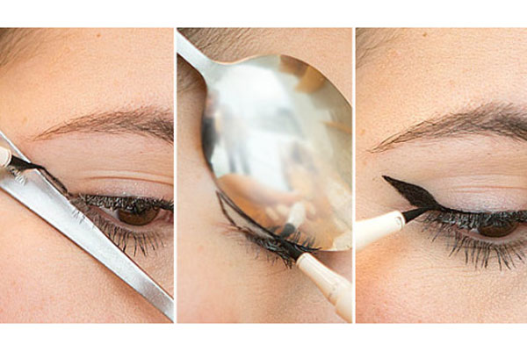***8. Amp up your going-out makeup by contouring and highlighting your facial features with two concealers: one two shades darker than your skin tone and one two shades lighter.***

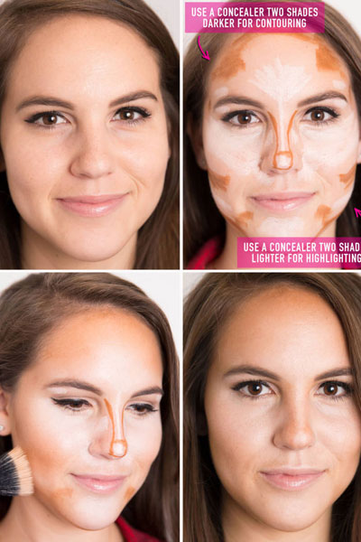If you're using pencil concealers, you have more control of the placement, which makes contouring easy. Just draw the lighter shade of concealer on the areas that naturally catch light, and use a darker one to shade in the areas that are naturally shaded. Then, blend with a buffing brush like this one from Tarte Cosmetics.

***9.Fix foundation stains with a little bit of shaving cream.***

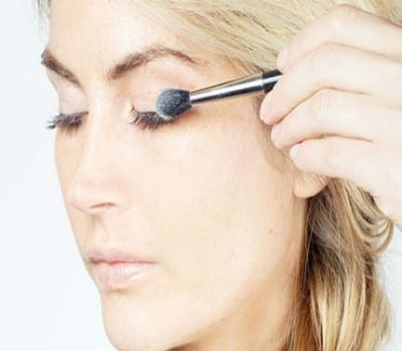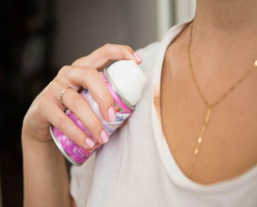If you take off your shirt and accidentally smudge your makeup on the collar, just wipe a dollop of shaving cream on the spot to pretreat it before tossing it in the wash.

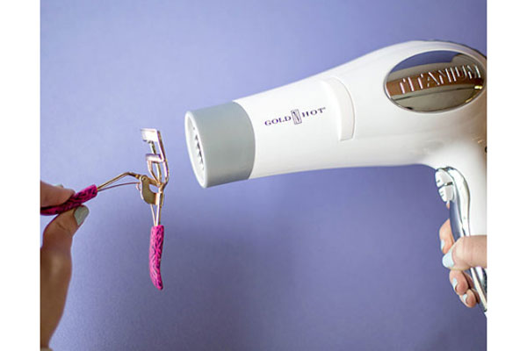***10. Hit your eyelash curler with a hair dryer to heat it up, so your lashes curl easier.***

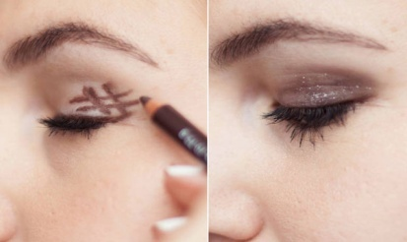

**4**

**11 a*. Turn a pencil eyeliner into a gel formula with the help of a match.***

Hold your black, green, burgundy, etc., kohl eye pencil (which typically creates a thin, harder-to-apply line), under the flame for one second, let it cool for 15 seconds, and then watch the consistency change right before your eyes. Glide on your newly made gel liner for an instantly smudgier formula.

***11b. Use the handle and the rounded edge of a spoon to create the perfect winged liner.***

Hold the handle of a spoon against the outer corner of your eye, and draw a straight line. Then, flip the spoon so it's hugging your eyelid, and use the rounded outer edge to create a perfectly curved, winged tip. After you've made your outline, fill it in, and draw a line across your lashline to finish the look.

***12.Dust baby powder over your eyelashes between the first and second coats of mascara to plump up your lashes.***

***13. Get the perfect smoky eye by drawing a hash tag on the outer corner of your eyelid and smudging it out with the sponge*.**